Introduction to Digital Logic

EECS/CSE 31L

**Assignment 3: 32-Bit ALU**

Prepared by: Jack Melcher

Student ID: 67574625

EECS Department

Henry Samueli School of Engineering

University of California, Irvine

February 7, 2015

**1 Block Description**

Take in two 32-bit values (a and b) and 4 select values in order to perform a variety of operations

**2 Input/Output Port Description**

|  |  |  |  |
| --- | --- | --- | --- |
| Port name | Port size | Port Type | Description |
| A | 31 downto 0 | IN | Value of first input |
| B | 31 downto 0 | IN | Value of second input |
| Cin | 1 | INOUT | The carry in value |
| opsel | 2 downto 0 | IN | Determine which operation to perform in units |
| mode | 1 | OUT | Determine whether the output is from arithmetic operation or logic operation |
| cout | 1 | OUT | The carry out value |
| output | 31 downto 0 | OUT | The output value of operation |

**3 Design Schematics**

**Truth Tables:**

ALU Operations

|  |  |  |  |
| --- | --- | --- | --- |
| **Mode** | **OPSEL** | **Micro-operation** | **Description** |
| 0 | 000 | a+b | Add |
| 0 | 001 | a+b' | Sub with borrowed carry |
| 0 | 010 | a | Move |
| 0 | 011 | a+b'+1 | Sub |
| 0 | 100 | a+1 | increment |
| 0 | 101 | a-1 | decrement |
| 0 | 110 | a+b+1 | Add & Increment |
| 1 | 000 | a AND b | Bit-wise AND |
| 1 | 001 | a OR b | Bit-wise OR |
| 1 | 010 | a XOR b | Bit-wise Exclusive OR |
| 1 | 011 | a' | Compliment |
| 1 | 101 | shl a | 1 Bit Shift Left |

Cin table

|  |  |  |
| --- | --- | --- |
| Opsel | cin | **Description** |
| 000 | 0 | Add |
| 001 | 1 | Sub with borrowed carry |
| 010 | 0 | Move |
| 011 | 1 | Sub |
| 100 | 1 | increment |
| 101 | 0 | decrement |
| 110 | 1 | Add & Increment |

Full Adder

|  |  |  |  |  |
| --- | --- | --- | --- | --- |
| In_0 | In_1 | Cin | Cout | Sum |
| 0 | 0 | 0 | 0 | 0 |
| 0 | 0 | 1 | 0 | 1 |
| 0 | 1 | 0 | 0 | 1 |
| 0 | 1 | 1 | 1 | 0 |
| 1 | 0 | 0 | 0 | 1 |
| 1 | 0 | 1 | 1 | 0 |
| 1 | 1 | 0 | 1 | 0 |
| 1 | 1 | 1 | 1 | 1 |

Two’s Complement Full Adder/Subtractor

|  |  |  |  |  |
| --- | --- | --- | --- | --- |
| In_0 | In_1 | Cin | Cout | Sum |
| 0 | 0 | 0 | 0 | 0 |
| 0 | 1 | 0 | 0 | 1 |
| 1 | 0 | 0 | 0 | 1 |
| 1 | 1 | 0 | 1 | 0 |
| 0 | 0 | 1 | 1 | 0 |
| 0 | 1 | 1 | 0 | 1 |
| 1 | 0 | 1 | 1 | 1 |
| 1 | 1 | 1 | 1 | 0 |

**Boolean Expressions:**

Full Adder

Sum = (A ⊕ B) ⊕ Cin

Cout = (A)(B) + (Cin)(A ⊕ B)

**Design:**

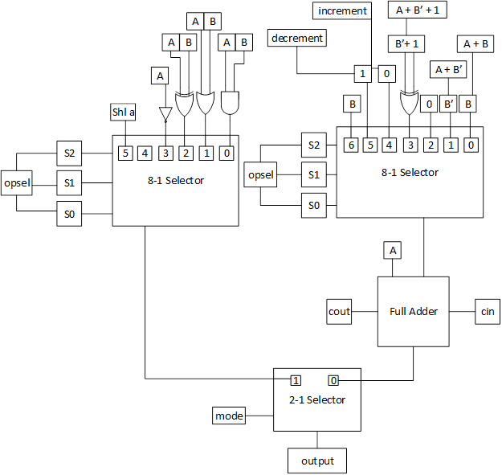

**4 Compilation**

Arithmetic unit

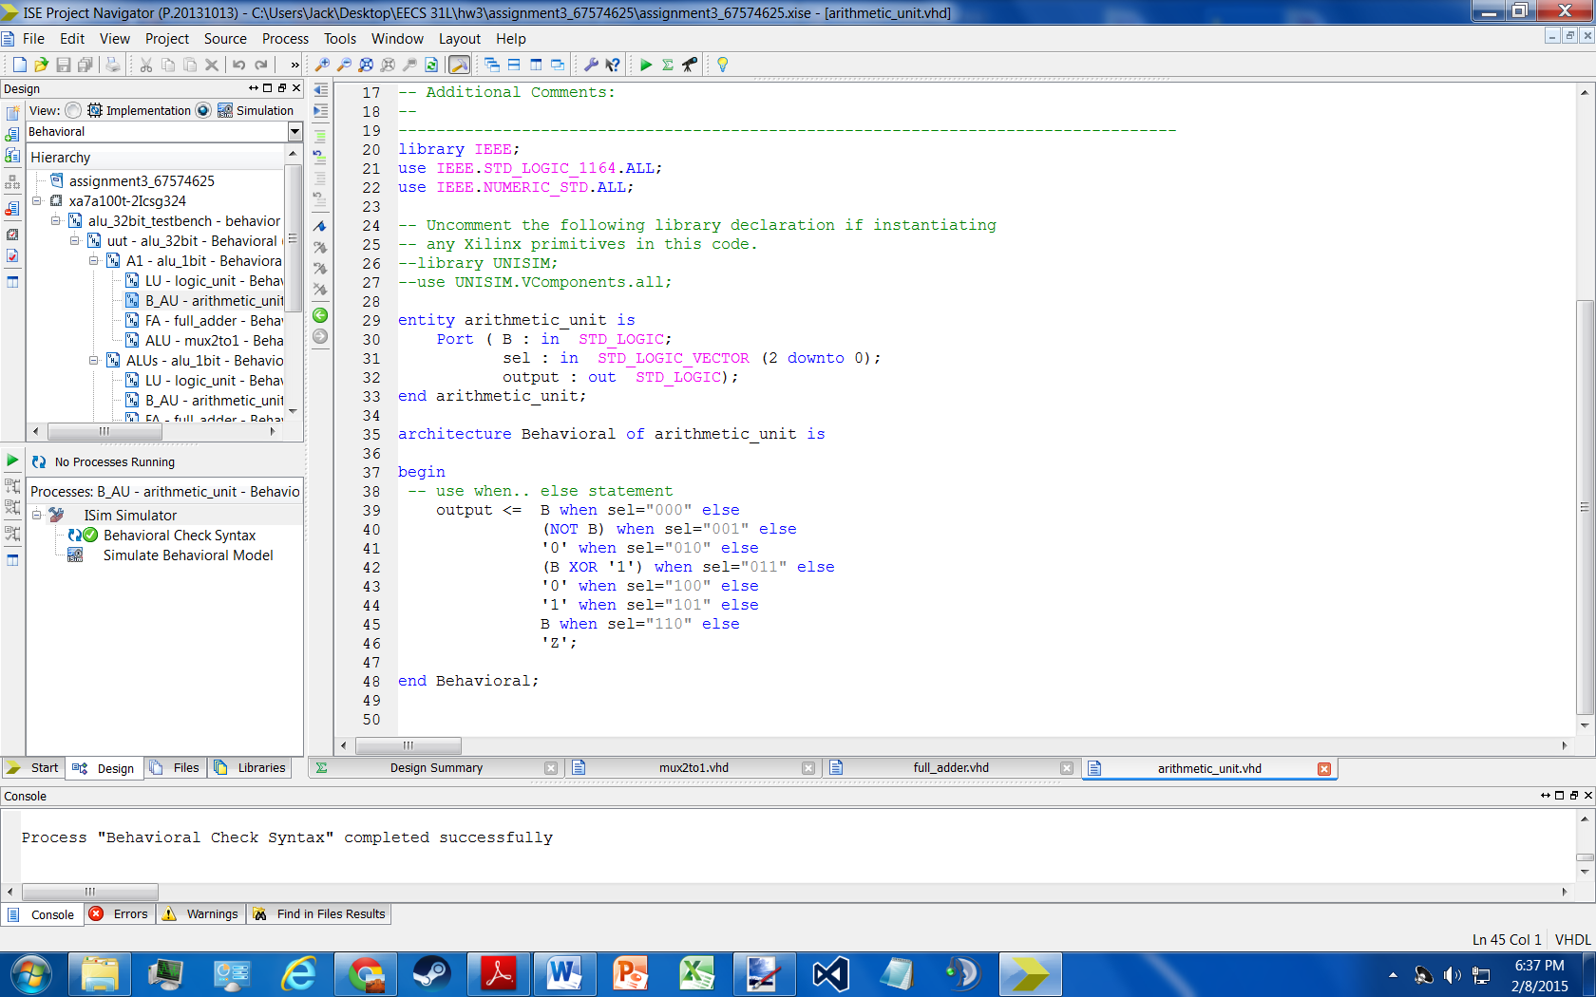

Full Adder

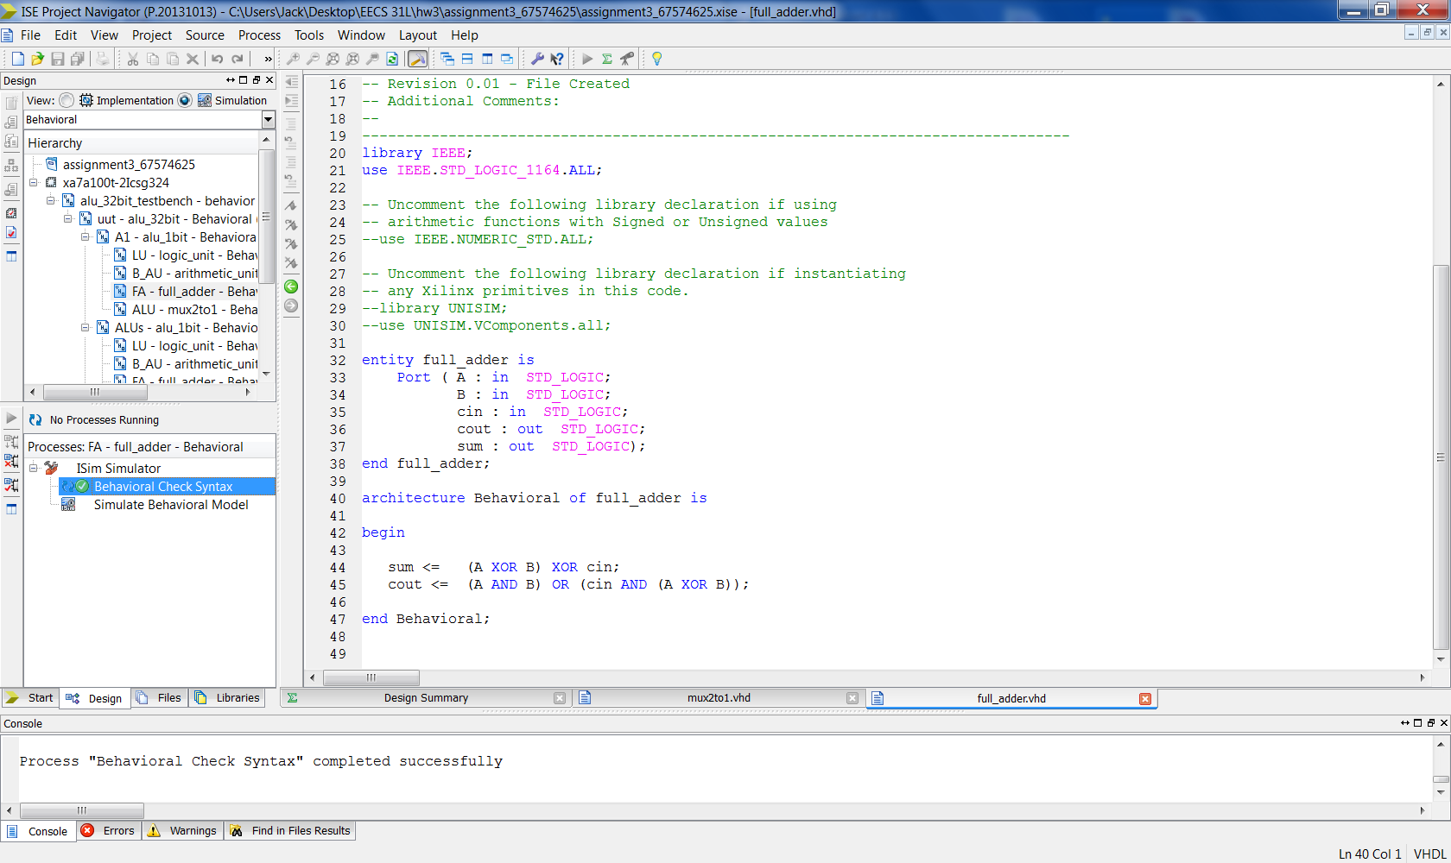

Logic unit

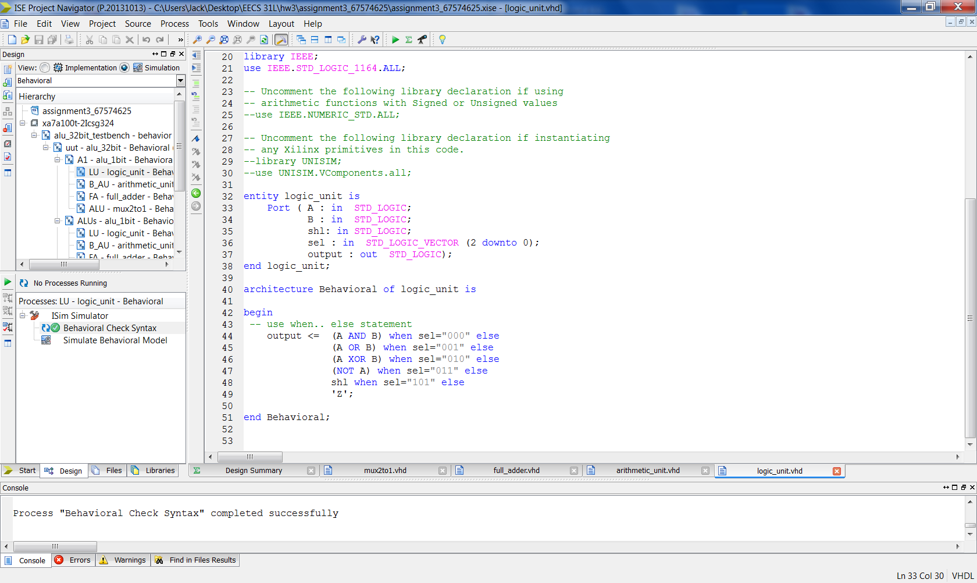

Mux 2to1

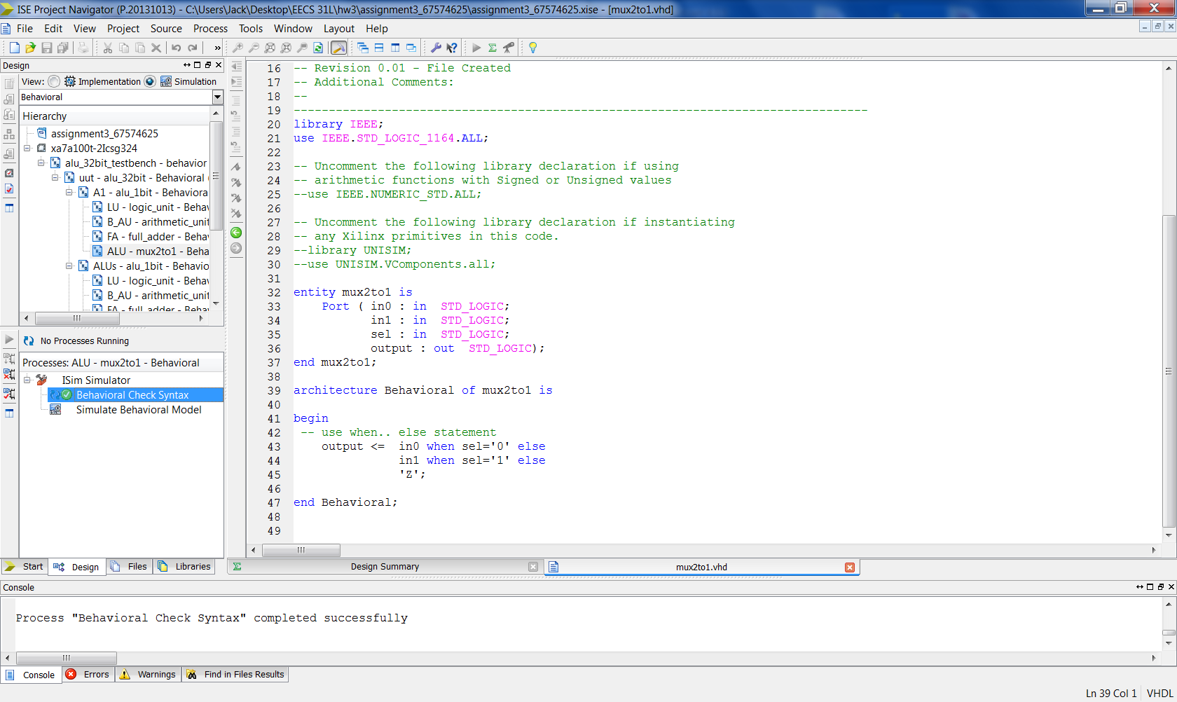

ALU 1bit

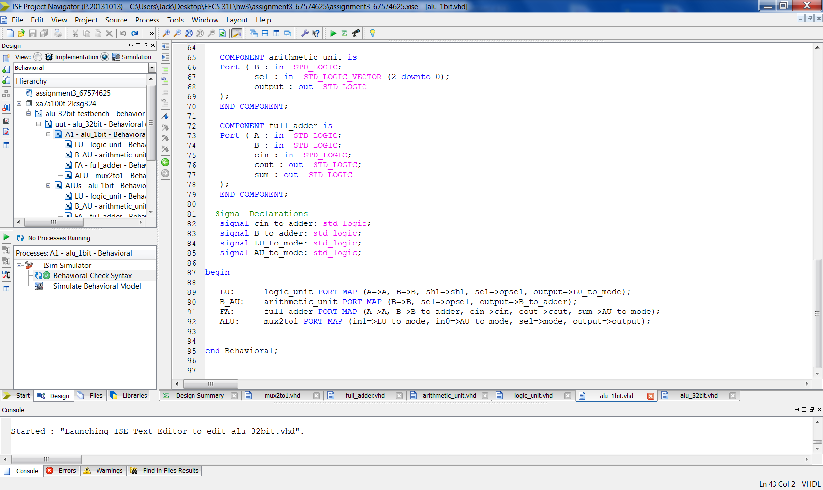

ALU 32bit

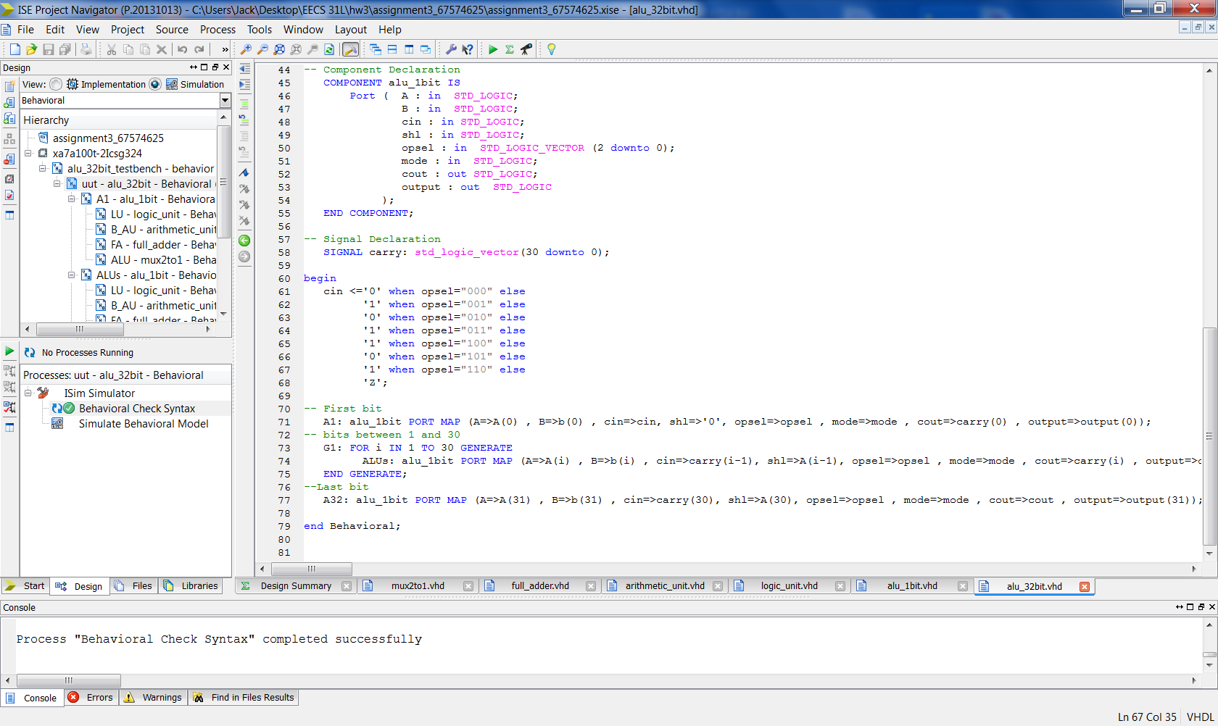

Testbench

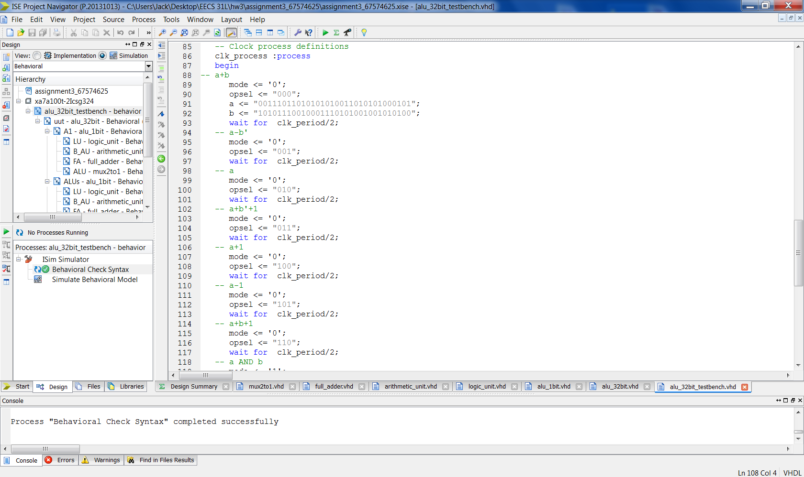

**5 Elaboration**

**Assumptions:**

Value of cin

* I change cin from an IN port type to an INOUT port type. This way I could assign it a specific value that correlated to the function.

Arithmetic

* a+b is just the full adder
* a +b’ is just the full adder and will only subtract properly with cin = 1
* a+b’+1 subtraction is like two’s complement full adder/subtractor; cin = 1 and b XOR 1
* Move A will only work properly if cin = 0
* To properly increment a number a 1-bit, A = A, B = 0 and cin = 1
* To properly decrement a number a 1-bit, A = A, B = 1, and cin = 0
* To properly add and increment, A = A, B = 0, and cin = 1
* For a+b+1 to work properly, cin = 1

Logic

* Because A is now multiple bits, only the first bit becomes zero and the rest get shifted over to the left

ALU 1bit

* cin port type in the 1bit ALU was changed from INOUT to just IN
* Added in a shl IN port in order to be able to shift multiple bits

Regarding how I wrote my vhdl code

* I wrote 4 components and then the top level ALU 1bit
* And then ontop of that, ALU 32bit top level vhdl file with a for generate loop
* The cin value set was moved to the 32bit ALU
* Arithmetic unit that selects vale of b
* Full adder to handle the addition/subtraction
* Logic unit that selects logic operation
* And a 2to1 mux that uses mode to pick the final output.

**Errors and Challenges:**

* I had to learn how to use multiple vhdl modules, signals, component declarations, and port mapping in order for my alu to function properly
* Ran into errors about with setting up proper signaling and connecting components properly
* I was confused on how to properly set cin value within ALU and not the testbench. I went through a lot of trial and error in order to figure this out. I ended up changing cin
* Figuring out that I needed an ALU module just for the First, and Last, and a for generate for the rest of the bits inbetween
* Properly setting up a for generate loop allowing the carryout to go to the carryin

**Simulation Log:**

Started : "Simulate Behavioral Model".

Determining files marked for global include in the design...

Running fuse...

Command Line: fuse -intstyle ise -incremental -lib secureip -o {C:/Users/Jack/Desktop/EECS 31L/hw3/assignment3_67574625/alu_32bit_testbench_isim_beh.exe} -prj {C:/Users/Jack/Desktop/EECS 31L/hw3/assignment3_67574625/alu_32bit_testbench_beh.prj} work.alu_32bit_testbench {}

Running: C:\Xilinx\14.7\ISE_DS\ISE\bin\nt64\unwrapped\fuse.exe -intstyle ise -incremental -lib secureip -o C:/Users/Jack/Desktop/EECS 31L/hw3/assignment3_67574625/alu_32bit_testbench_isim_beh.exe -prj C:/Users/Jack/Desktop/EECS 31L/hw3/assignment3_67574625/alu_32bit_testbench_beh.prj work.alu_32bit_testbench

ISim P.20131013 (signature 0x7708f090)

Number of CPUs detected in this system: 4

Turning on mult-threading, number of parallel sub-compilation jobs: 8

Determining compilation order of HDL files

Parsing VHDL file "C:/Users/Jack/Desktop/EECS 31L/hw3/assignment3_67574625/mux2to1.vhd" into library work

Parsing VHDL file "C:/Users/Jack/Desktop/EECS 31L/hw3/assignment3_67574625/logic_unit.vhd" into library work

Parsing VHDL file "C:/Users/Jack/Desktop/EECS 31L/hw3/assignment3_67574625/full_adder.vhd" into library work

Parsing VHDL file "C:/Users/Jack/Desktop/EECS 31L/hw3/assignment3_67574625/arithmetic_unit.vhd" into library work

Parsing VHDL file "C:/Users/Jack/Desktop/EECS 31L/hw3/assignment3_67574625/alu_1bit.vhd" into library work

Parsing VHDL file "C:/Users/Jack/Desktop/EECS 31L/hw3/assignment3_67574625/alu_32bit.vhd" into library work

Parsing VHDL file "C:/Users/Jack/Desktop/EECS 31L/hw3/assignment3_67574625/alu_32bit_testbench.vhd" into library work

Starting static elaboration

Completed static elaboration

Compiling package standard

Compiling package std_logic_1164

Compiling package numeric_std

Compiling architecture behavioral of entity logic_unit [logic_unit_default]

Compiling architecture behavioral of entity arithmetic_unit [arithmetic_unit_default]

Compiling architecture behavioral of entity full_adder [full_adder_default]

Compiling architecture behavioral of entity mux2to1 [mux2to1_default]

Compiling architecture behavioral of entity alu_1bit [alu_1bit_default]

Compiling architecture behavioral of entity alu_32bit [alu_32bit_default]

Compiling architecture behavior of entity alu_32bit_testbench

Time Resolution for simulation is 1ps.

Waiting for 1 sub-compilation(s) to finish...

Compiled 16 VHDL Units

Built simulation executable C:/Users/Jack/Desktop/EECS 31L/hw3/assignment3_67574625/alu_32bit_testbench_isim_beh.exe

Fuse Memory Usage: 35984 KB

Fuse CPU Usage: 592 ms

Launching ISim simulation engine GUI...

"C:/Users/Jack/Desktop/EECS 31L/hw3/assignment3_67574625/alu_32bit_testbench_isim_beh.exe" -intstyle ise -gui -tclbatch isim.cmd -wdb "C:/Users/Jack/Desktop/EECS 31L/hw3/assignment3_67574625/alu_32bit_testbench_isim_beh.wdb"

ISim simulation engine GUI launched successfully

Process "Simulate Behavioral Model" completed successfully

**6 Waveforms**

Full Waveform Snapshot 1

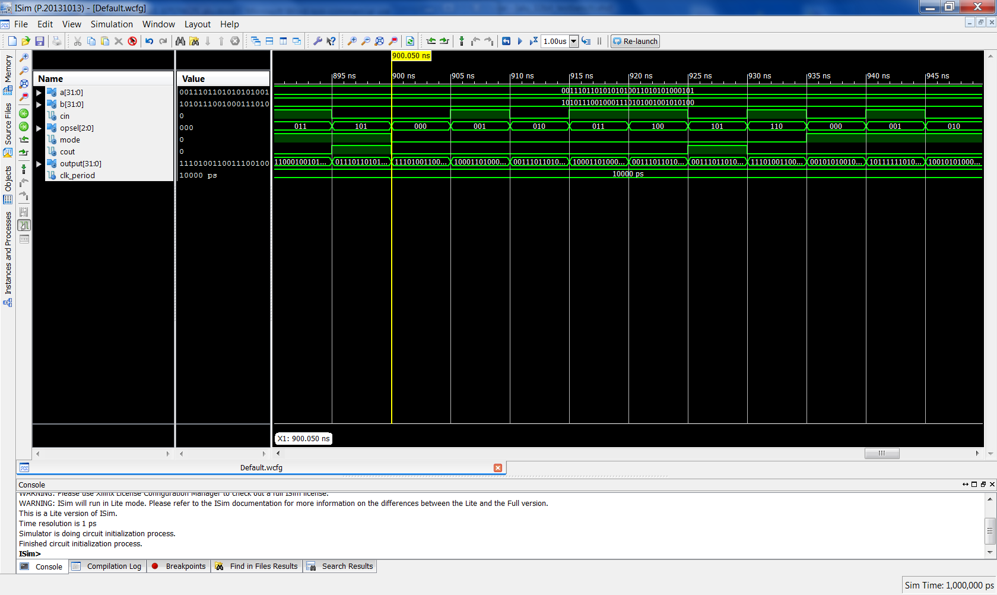

Full Waveform Snapshot 2

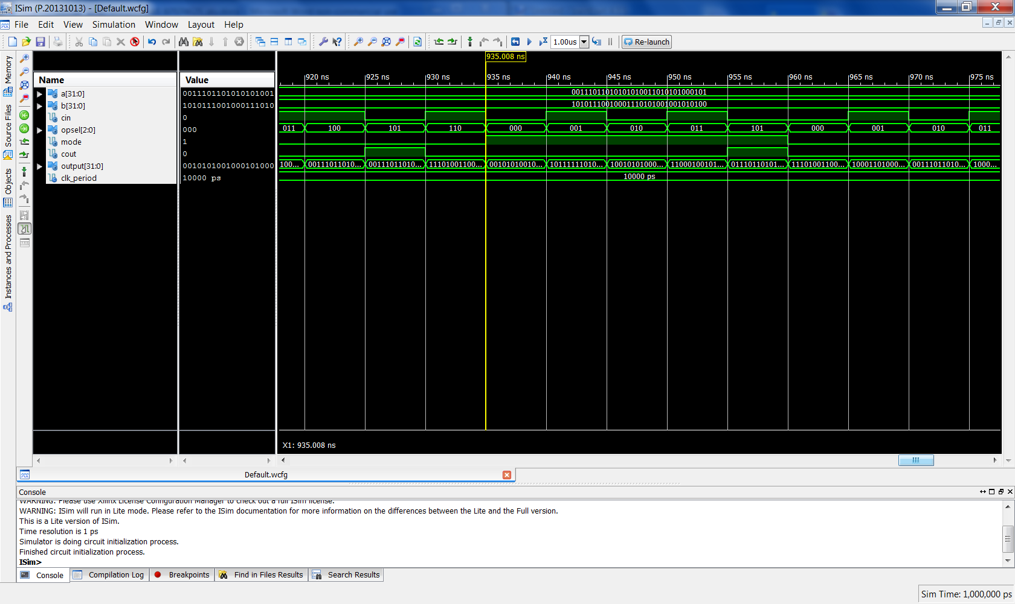

Snapshots of Waveform

a+b

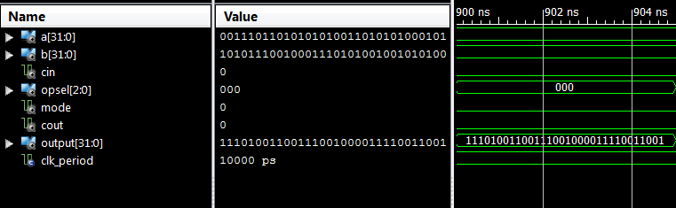

a-b'

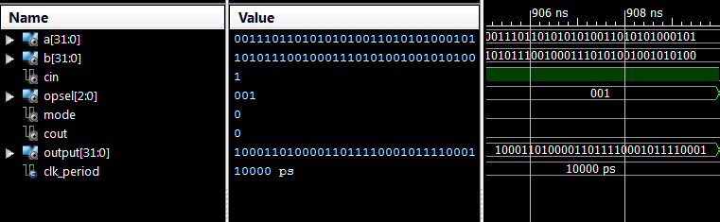

a

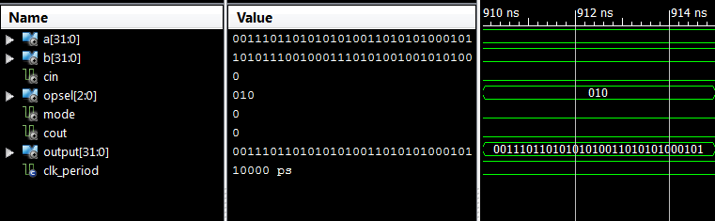

a+b'+1

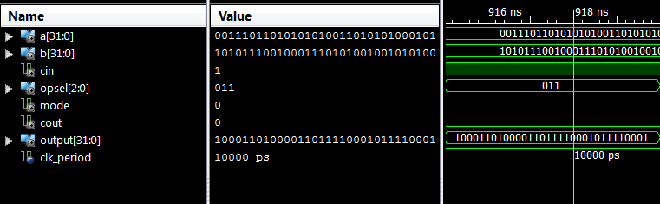

a+1

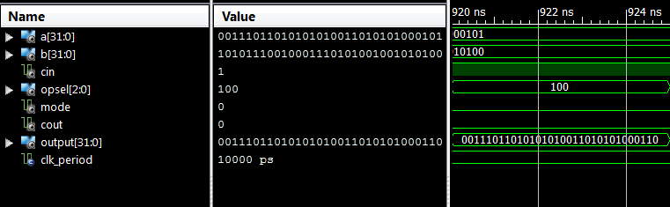

a-1

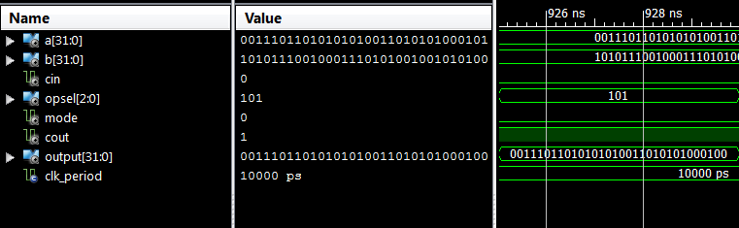

a+b+1

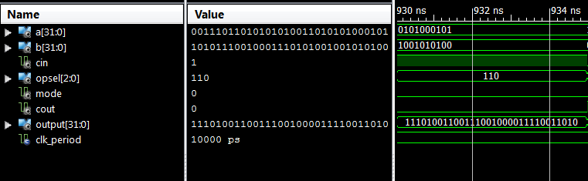

a AND b

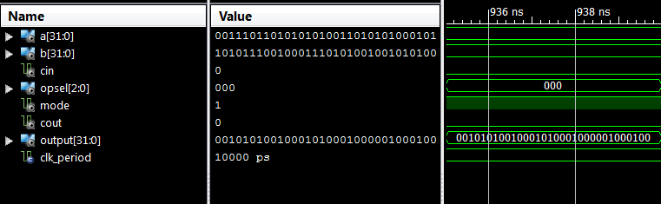

a OR b

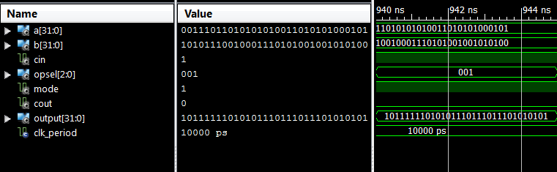

a XOR b

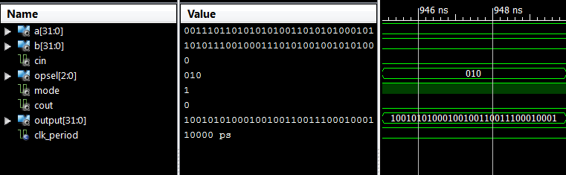

a'

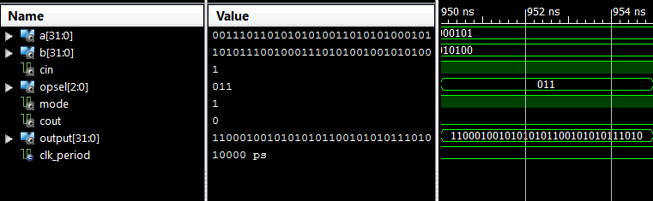

shift left a

